ELEC-2110

Electric Circuit Analysis

FROM: Jacob Howard

TO: Markus Kreitzer

DATE: September 18, 2019

LAB SECTION: 002

***Electrical Measurements:***

***Thevenin Equivalent Circuits***

# Introduction

The Objective of this lab was to review and work with Thevenin’s and Norton’s theorems. We used black boxes with unknown circuits inside to test and confirm Thevenin’s and Norton’s theorems.

# Exercise 1

In exercise 1, we were asked to show the mathematical derivation for how we know the voltage at two nodes will be VOC/2 when a resistor, Rload, is connected to those nodes that is equal to RTh.

***Insert Calculations***

# Exercise 2

In exercise 2, we were asked to measure and record the resistance between pin1 - pin2 and between pin2 – pin3 of your variable resistor [1]. The data is shown in Table 1 below.

|  |  |
| --- | --- |
| **Pin1 & Pin2** | 2.025 kΩ |
| **Pin2 & Pin3** | 8.0577 kΩ |
| **Pin1 & Pin3** | 9.8577 |
| **Sum of Pins 1&2 and Pins 2&3** | 10.0877 kΩ |

*Table 1*

# Exercise 3

In exercise 3, we were asked to experimentally determine the Thevenin equivalent circuit for the black box at terminals B1-B2. We were told to connect the 15V supply on the NI ELVIS Board to terminals A1-A2 as shown in the schematic in Figure. Turn on the component box and

*Figure 5*

# Exercise 4

In exercise 4, we were asked to find the Thevenin equivalent circuit between nodes A & B for the circuit shown in Figure 6. The circuit constructed in Multisim to verify Ix is shown in figure 7. Worked out solutions are shown in solutions 3[1].

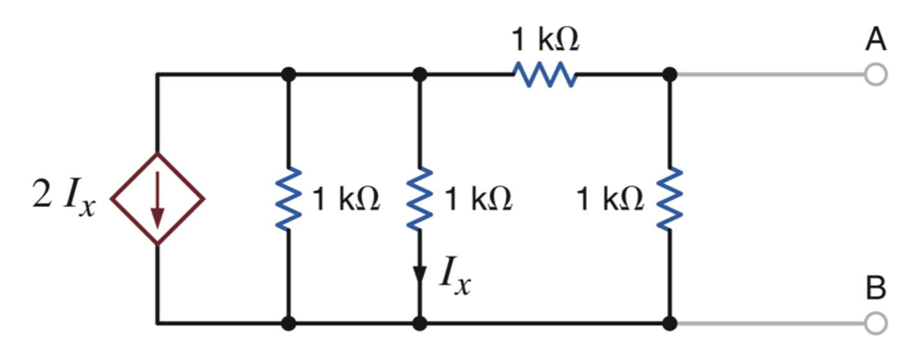

*Figure 6*

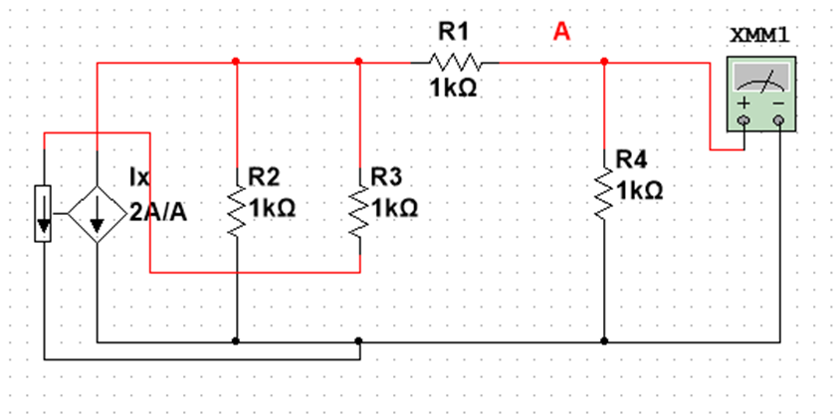

*Figure 7*

|  |  |
| --- | --- |
| **Calculated Resistance for Ix** | 555 Ohms |
| **Measured Resistance for Ix** | 555.556 Ohms |

*Table 3*

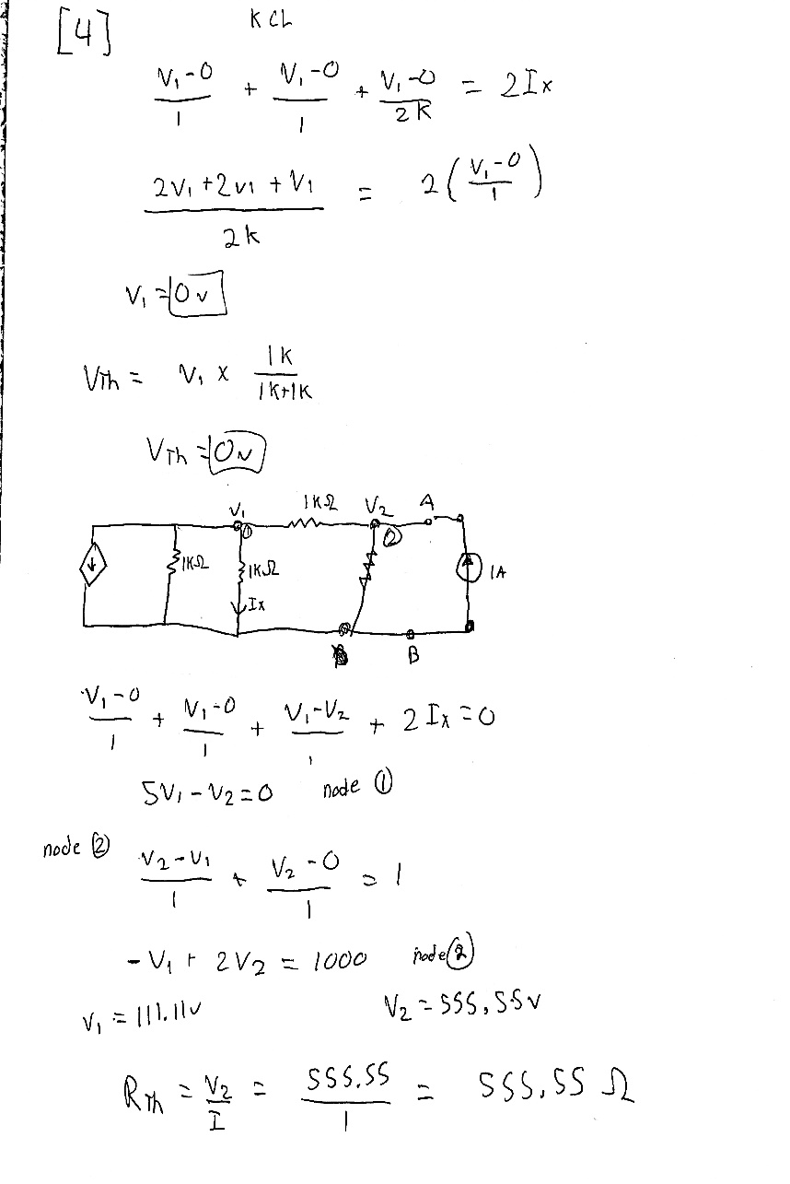

*Solutions 3*

# Exercise 5

In exercise 5, we were asked to find RL for maximum power transfer and the maximum power that can be transferred to RL (Pmax). The circuit is shown below in Figure 8 and the constructed circuit is shown in figure 9. Data is shown in table 4 and solutions are shown in Solutions 4 [1].

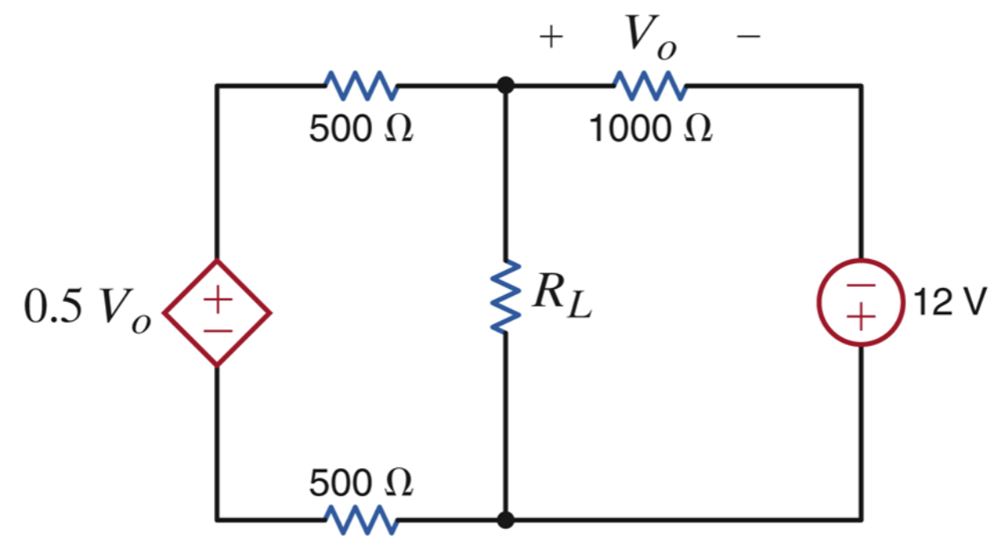

*Figure 8*

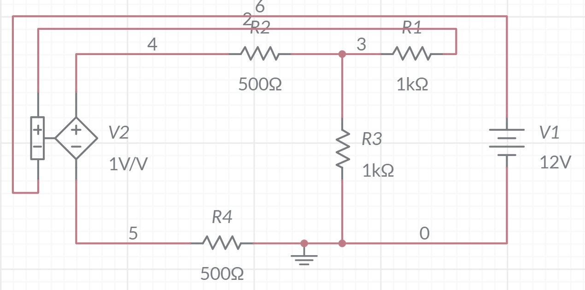

*Equations 3*

|  |  |
| --- | --- |
| **V0** | 8v |
| **VTh** | -4v |
| **I** | 8mA |
| **PRL** | 6mW |

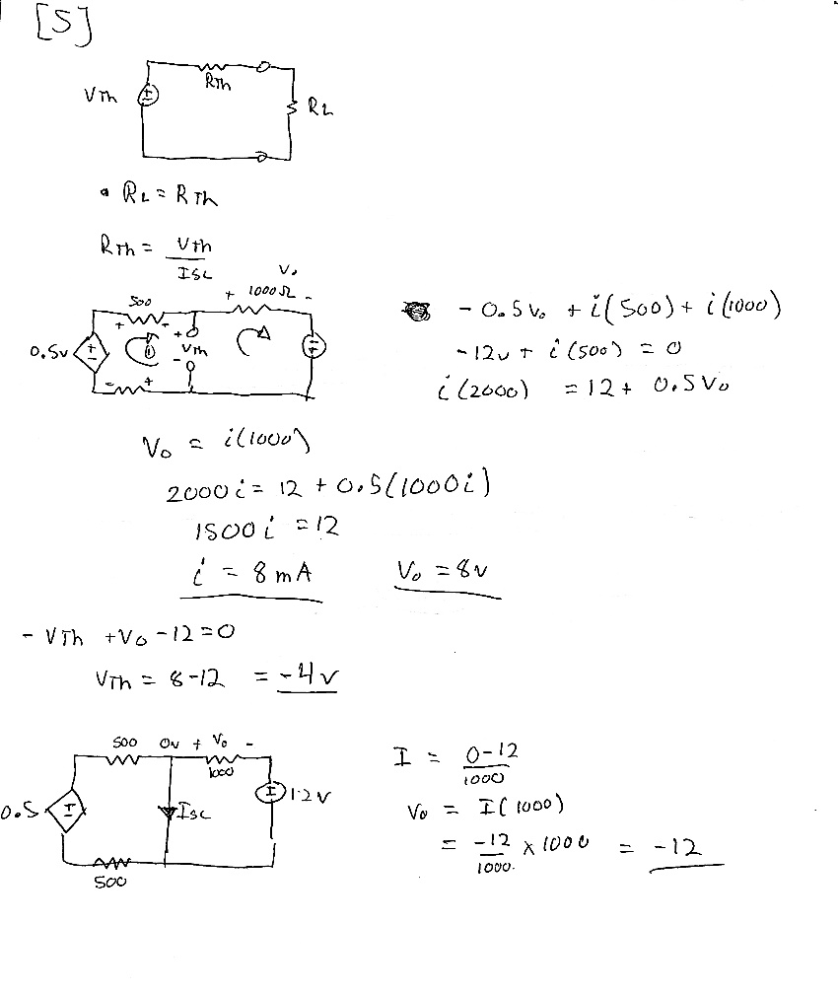

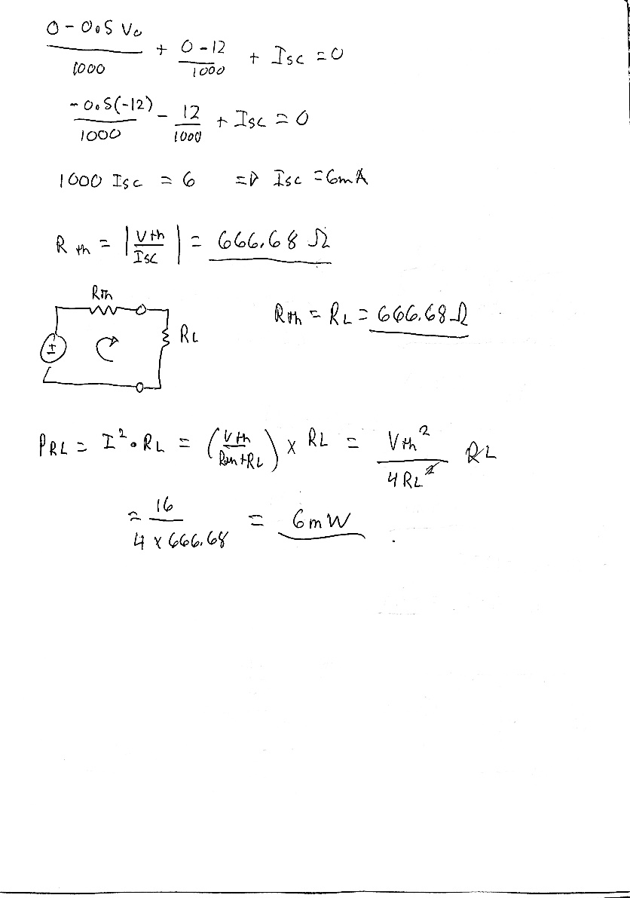

*Solutions 4*

# Conclusion

This lab was used as an overview of Thevenin’sand Norton’s theorem. We were given circuits and asked to calculate various things using Thevinin equations and then verify it through Multisim. I did have some struggles with this lab. The TA helped explain some things before we started so the lab was clearer.

# Bibliography

[1] Nelms, R. Mark, and Elizabeth Devore. *Recitation & MultiSim: Thevenin’s and Norton’s Theorems*. 2016, p. 5, Accessed 4 Sept 2019.